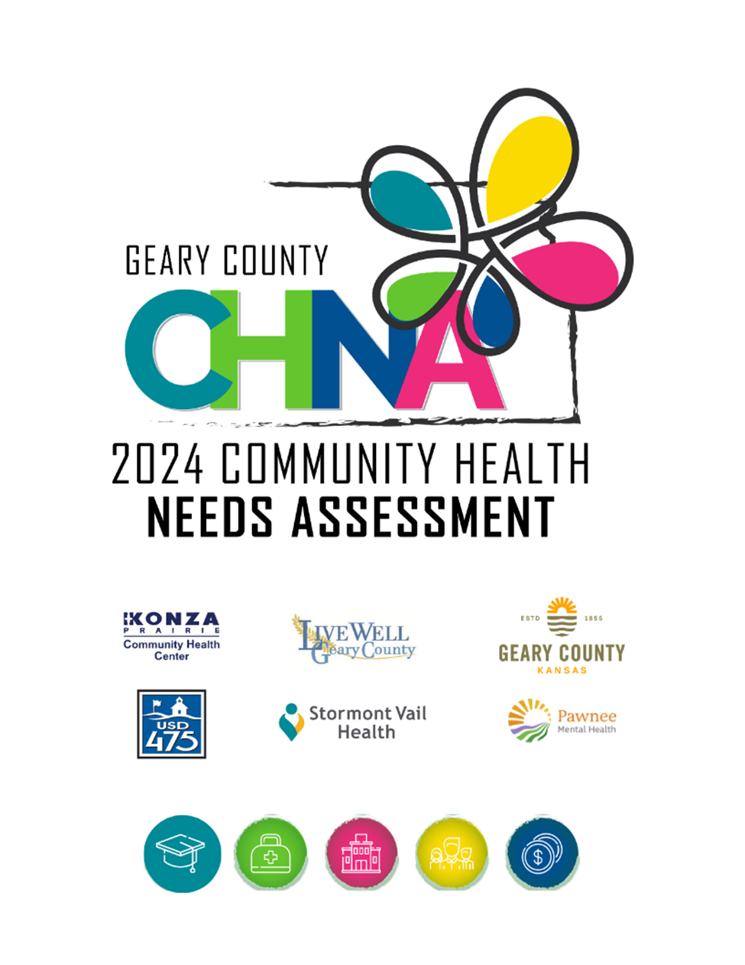

**Contents**

Executive Summary………………………………………………………………………………………………...………………………………..…….2

Introduction…………………………………………………………………………………………………………………………………….……………….3

Impact of Actions Taken on Prior CHNA…………………………………………………………………………………….………………….....4

Process of 2024 CHNA……………………………………………………………………………………………………………………………………….4

* Geary County Community Health Assessment Steering Committee……………………………………….………….….4
* Inclusivity and Representation……………………………………………………………………………...……………..…………….…4
* Methodology………………………………………………………………………………………………………………………………………...4
  + Formal and Electronic Perception Surveys………………………………………………………………..…………….…5
  + Roundtables………………………………………………………………………………………………………………..…............9
  + Data Analysis……………………………………………………………………………………………………..…………………….11
  + Town Hall Prioritizations Process…………………………………………………………………..…………………………13

Description of Identified Priority Areas………………………………………………………………………………..……………………….…14

* Access to Community Resources…………………………………………………………………………………………………………14
* Youth Character Development……………………………………………………………………………………………………………15
* Transportation……………………………………………………………………………………………………………………………………16
* Obesity……………………………………………………………………………………………………………………………………………….17
* Mental Health…………………………………………………………………………………………………………………………………….18

Community Profile………………………………………………………………………………………………………………………………………….19

* Geary County (KS) Community Profile…………………………………………………………………………………….……………19
* Demographic Profile……………………………………………………………………………………………………………………………20
* Health System Patient Draw………………………………………………………………………………….…………………………….21

Conclusion and Next Steps………………………………………………………………………………………………….…………………………..24

Appendix………………………………………………………………………………………………………………………………………….……………..25

* Appendix I- Full Survey…………………………………………………………………………………………………………….………….25
* Appendix II- Primary Care Service Available in Geary County…………………………………………….………………..29
* Appendix III- Roundtable Slide Deck…………………………………………………………………………….……………………..30
* Appendix IV- Organization Profiles…………………………………………………………………………………………..………….36

Process to Provide Feedback…………………………………………………………………………………………………..………………………41

**Executive Summary**

A comprehensive Community Health Needs Assessment (CHNA) was conducted for Geary County, Kansas in the Spring of 2024. A Steering Committee, comprised of representatives from Stormont Vail Health, Konza Prairie Community Health Center, Live Well Geary County Coalition, Pawnee Mental Health, Geary County Health Department, and USD 475, planned and implemented the comprehensive CHNA.

The CHNA included:

* **601 Perception Survey responses** providing feedback on access to care, preventive care, social determinants of health, income, and demographics
* **Eight Roundtables with under-represented voices that included 65 residents** providing feedback on community strengths, quality of care, concerns, underlying reasons for poor health, and suggested improvements
* **Data analysis** including review of recently released County Health Rankings
* **Town Hall** **event including 75 stakeholders representing over 40 organizations** to review all of the Survey and Roundtable results and County Health Ranking data. The event concluded with a prioritization exercise.

Identified Priorities:

The following most significant community health needs were determined the top community health priorities by stakeholders attending the Town Hall:

* **Access to Community Resources**
* **Youth Character Development**
* **Transportation**
* **Obesity**
* **Mental Health**

Next Steps:

Work on the Community Health Implementation Plan (CHIP) will begin in the fall of 2024 and will be completed in 2025 identifying objectives and strategies to address each need over the next three years. In addition, Stormont Vail Health Flint Hills Campus developed a Hospital Implementation Plan outlining strategies the hospital will undertake over the next three years to address each of the identified priorities.

Documentation:

The CHNA, Hospital Implementation Plan, and CHIP (when completed) are available in hard copy at each of the Steering Committee member organizations and can be found on the Stormont Vail Health website, in addition to the websites of the individual Steering Committee member organizations. Any feedback should be directed to Karla Hedquist, Director Community Health Engagement at Stormont Vail Health, by email to [khedquis@stormontvail.org](mailto:khedquis@stormontvail.org).

### Introduction:

A Community Health Needs Assessment (CHNA) is an important tool used for examining and improving the health of a community. It provides insight into the current health status of a community by identifying needs and potential means of fulfilling them. The CHNA includes comprehensive information about health risks and outcomes based on systematic collection and analysis of data and conversations with community members and leaders. A Steering Committee comprised of representatives from Stormont Vail Health, Konza Prairie Community Health Center, Live Well Geary County, Pawnee Mental Health, Geary County Health Department, and USD 475, determined and implemented the method of collecting information for the 2024 CHNA.

Geary County is home to an estimated 36,739 residents. The 2024 CHNA included a perception survey completed by 601 community members, feedback from 8 roundtables with 65 under-represented voices, a Town Hall community conversation attended by 75 individuals, representing over 40 organizations, and data compiled from County Health Rankings and Kansas Health Matters.

The information collected in the CHNA drives the development of a Community Health Improvement Plan (CHIP). A CHIP details available resources and how they should be allocated in order to address community health issues. Together the CHNA and CHIP will educate community members, prioritize community health improvement methods, drive policy change, promote equity, and outline resources to promote better health in Geary County.

In addition to identifying and addressing community health issues, a CHNA fulfills a requirement for local health departments seeking accreditation from the National Public Health Accreditation Board (PHAB), Federally Qualified Health Center accreditation, and Certified Community Behavioral Health Center designation. The federal Patient Protection and Affordable Care Act (ACA) requires that each registered 501(c)3 hospital conduct a CHNA at least once every three years and adopt a strategy to meet identified needs.

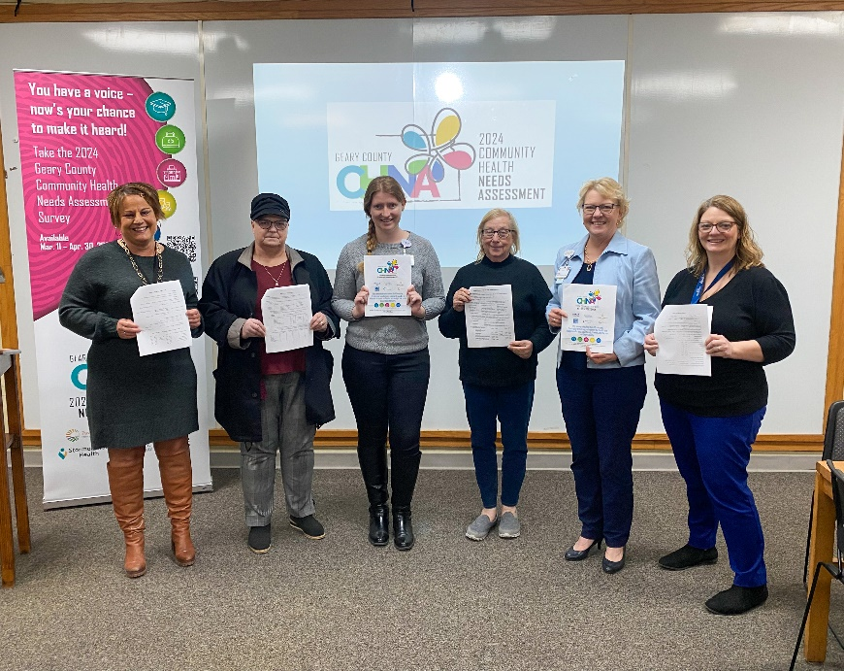

**Impact of Actions Taken on Prior Community Health Needs Assessment**

Geary Community Hospital leadership chose to address five of the ranked health needs from their 2021 CHNA:

1. Access to Primary and Specialty Care Services and Providers
2. Access to Affordable Care and Reducing Health Disparities Among Specific Populations
3. Increased Emphasis on Education and Awareness of Existing Health Care Resources
4. Access to Mental and Behavioral Health Care Providers and Services
5. Prevention, Education and Services to Address High Mortality Rates, Chronic Diseases, Preventable Conditions and Unhealthy Lifestyles

The 2021 CHNA and Hospital Implementation Plan was developed by Geary Community Hospital. In January of 2023, Stormont Vail Health assumed leadership of the hospital as a new entity which is now named Stormont Vail Health Flint Hills Campus. Given the transition of hospital governance, progress made by Geary Community Health on the 2021 CHNA priorities is not available.

### 2024 Geary County Community Health Needs Assessment Process

### Geary County Community Health Needs Assessment Steering Committee

In 2023, the Geary County Community Health Assessment (CHNA) Steering Committee, led by Stormont Vail Health, included collaborative participation from several community-based organizations: Konza Prairie Community Health Center, Live Well Geary County, Pawnee Mental Health, Geary County Health Department, and USD 475. This diverse coalition aimed to comprehensively assess and address the health needs of the Geary County community.

### Inclusivity and Representation

The primary objective of the CHNA Steering Committee was to ensure inclusivity and representation, particularly from traditionally under-represented communities, including those who are low-income, minorities, and organizations assisting those neighbors. To address this, the CHNA planning team meticulously designed the data collection process to better capture a representative sample of the community demographics.

### Methodology

### Collaboration and Community Engagement

The CHNA process emphasized collaboration with various organizations and the inclusion of representatives from government, public health, low-income communities, minority groups, and organizations serving these populations. This collaborative approach ensured a broad spectrum of community voices were heard and considered. The data collection process comprised four major steps:

#### 1. Formal and Electronic Perception Surveys

Surveys were conducted from March 11 to April 30, 2024, focusing on various health and social concerns, including access to care, preventive care, income, and participant demographics. The survey, created using SurveyMonkey, was distributed through multiple channels:

* **Kickoff party at Dorothy Bramlage Public Library**
* **Press Releases**: Containing survey links and QR codes.
* **QR Code Business Cards**: Two-sided business cards with English on one side and Spanish on the other that were distributed by community partners.
* **Email Distribution**: Utilizing lists generated by the steering committee, the Stormont Vail Health CEO emailed survey links to over 185 contacts.
* **Mass Emails**: Survey links were cascaded by email by Stormont Vail, Konza Prairie Community Health Center, Live Well Geary County, Pawnee Mental Health, USD 475 and the Junction City Area Chamber of Commerce.
* **Paper Surveys**: Available at all partner locations, food distribution sites, and in large print for senior centers. Other translated languages available were Dari, Pashto, Haitian, Korean and Spanish

### Organizations Surveyed

The organizations and their constituents surveyed included but were not limited to:

* Fresh Start Emergency Shelter
* Free community meal sites including: Breaking Bread, and the Episcopal church dinner
* Bicentennial Manor
* Laundry Love
* Steering Committee organizations: Stormont Vail Health Flint Hills Campus, Konza Prairie Community Health Center, Live Well Geary County Coalition, Pawnee Mental Health, Geary County Health Department, and USD 475
* Various community partners via email distribution including: City of Junction City, City of Milford, Junction City Area Chamber of Commerce, Geary County Ministerial Association and Junction City Main Street
* Blue Cross and Blue Shield of Kansas
* Junction City employers of various sizes

Survey Analysis

2024 CHNA Survey Results

The 2024 CHNA was divided into three sections: Access to Care, Social Determinates of Health, and Demographics. Following are the results from each of the sections. The full survey can be found in Appendix I.

Access to Care

**Where do you usually go for Non-Emergency Medical Care:**

|  |  |
| --- | --- |
| Answer | # Of responses |
| Personal/ Private Doctor | 69 |
| Immediate/ Express Care | 42 |
| Private Clinics (Blue River, Stone Creek) | 131 |
| Other | 106 |
| Did not seek medical care | 24 |
| Emergency department | 17 |
| Nonprofit community clinic | 89 |
| Retail Provider | 10 |
| Total | 488 |

**In the past 12 months, did you need any following services:**

|  |  |
| --- | --- |
| Answer | # Of responses |
| Medical Care | 402 |
| Prescription Medication | 402 |
| Dental Care | 348 |
| Counseling | 165 |
| Quitting Tobacco/nicotine | 23 |
| Substance/ opioid use | 4 |
| total | 1344 |

**If you checked needing a service above, was it received:**

|  |  |
| --- | --- |
| Answer | # Of responses |
| Medical Care | 363 |
| Prescription Medication | 376 |
| Dental Care | 295 |
| Counseling | 132 |
| Quitting Tobacco/nicotine | 14 |
| Substance/ opioid use | 3 |
| total | 1183 |

**If you did not receive care, why not?**

|  |  |
| --- | --- |
| Answer | # Of responses |
| Care was too expensive | 29 |
| Did not seek care | 31 |
| Other (answers all vary) | 25 |
| Care was not available | 14 |
| Lack of transportation | 13 |
| My language was not available | 1 |

Preventative Care

For each of the health procedures, please indicate the last time procedure was done:

|  |  |  |  |  |  |
| --- | --- | --- | --- | --- | --- |
|  | Past 12 months | Last 1-5 yr. | More than 5 yr. | Never | N/A |
| Blood Pressure | 427 | 46 | 5 | 6 | 8 |
| Dental Screening | 304 | 99 | 47 | 6 | 14 |
| Flu Vaccine | 299 | 77 | 36 | 39 | 14 |
| COVID vaccine | 171 | 212 | 5 | 53 | 16 |
| Mammogram | 167 | 62 | 32 | 89 | 92 |
| Pap smear | 107 | 134 | 56 | 30 | 106 |
| Prostate exam | 31 | 27 | 16 | 92 | 248 |

Social Determinants of Health

Respondents were asked several questions to gauge the importance of specific issues that affect the health of our community. The responses show that the effects of social determinants of health, including affordable health insurance, poverty, and obesity were important factors to improve upon.

|  |  |
| --- | --- |
| **Top major/moderate concerns combined** | **# of responses** |
| 1 Adult Obesity | 155 |
| 2 Up to date information of available community services | 146 |
| 3 Mental Health | 144 |
| 4 Safe, Affordable, Accessible Housing | 140 |
| 5 Financial Assistance (Medical) | 135 |
| 6 Treatment of Chronic Conditions | 125 |
| 7 Youth development/ character building programs | 122 |
| 8 Food Assistance | 119 |
| 9 Disaster response (including shelter) | 119 |
| 10 Financial Assistance (housing/ utility) | 114 |

Survey Response Demographics Versus Percent of County Population

|  |  |  |  |
| --- | --- | --- | --- |
| **CHNA 2024 (n=601)** | | | **Geary Co Census 2023** |
|  | | | **Population:35,934** |
| **Gender Identity** | **# Replies 2024** | **% Replies 2024** | **Geary County %** |
| Female | 338 | 76.13% | 47.4% |
| Male | 102 | 22.97% |  |
| Non-Binary | 3 | 0.68% |  |
| Transgender | 1 | 0.23% |  |
| # Answered question | 444 | 100% |  |
| **Age** |  |  |  |
| Under 18 | 3 | 0.67% | 31.7% |
| 18-24 | 17 | 3.79% |  |
| 25-34 | 52 | 11.58% |  |
| 35-44 | 91 | 20.27% | 18-64= 59.1% |
| 45-54 | 78 | 17.37% |  |
| 55-64 | 76 | 16.93% |  |
| 65-74 | 88 | 19.60% | 65+ = 9.2% |
| 75-84 | 28 | 6.24% |  |
| 85 or older | 16 | 3.56% |  |
| # Answered question | 449 | 100% |  |
| **Race/Ethnicity** |  |  |  |
| Black or African American | 75 | 14.79% | 17.7% |
| American Indian or Alaska Native | 21 | 4.14% | 1.4% |
| Asian | 28 | 5.52% | 3.4% |
| Caucasian/White | 322 | 63.51% | 56.7% |
| Hispanic, Latino, or Spanish | 55 | 10.85% | 16.9% |
| Middle East | 2 | 0.39% | N/A |
| Native Hawaiian/Pacific Islander | 4 | 0.79% | 1.2% |
| # Answered question | 507 | 100% |  |
| **Household Income** |  |  |  |
| Less than $10,000 | 36 | 8.13% |  |
| $10,000-$14,999 | 33 | 7.45% |  |
| $15,000-$24,999 | 24 | 5.42% |  |
| $25,000-$34,999 | 42 | 9.48% |  |
| $35,000-$49,999 | 41 | 9.26% |  |
| $50,000-$74,999 | 62 | 14.00% | CO: Med household income: $57,992 |
| $75,000-$99,999 | 63 | 14.22% |  |
| $100,000-$149,999 | 75 | 16.93% |  |
| $150,000-$199,999 | 22 | 4.97% |  |
| $200,000 or more | 16 | 3.61% |  |
| Don't Know | 29 | 6.55% |  |
| # Answered question | 443 | 100% |  |

|  |  |  |
| --- | --- | --- |
| Zip Code | # of replies | % of Replies |
| 66441, Junction City | 468 | 90.35% |
| 66442, Fort Riley | 15 | 2.90% |
| 66514, Milford | 35 | 6.76% |

Summary of Common Themes

By engaging with a wide range of community voices and leveraging the strengths of various organizations, the CHNA Steering Committee was able to develop a comprehensive and inclusive survey assessment of Geary County's health needs. Common themes from participant input included:

|  |  |
| --- | --- |
| **Top major/moderate concerns combined** | **# of responses** |
| 1 Adult Obesity | 155 |
| 2 Up to date information of available community services | 146 |
| 3 Mental Health | 144 |
| 4 Safe, Affordable, Accessible Housing | 140 |
| 5 Financial Assistance (Medical) | 135 |
| 6 Treatment of Chronic Conditions | 125 |
| 7 Youth development/ character building programs | 122 |
| 8 Food Assistance | 119 |
| 9 Disaster response (including shelter) | 119 |
| 10 Financial Assistance (housing/ utility) | 114 |

#### 2. Roundtables

The Steering Committee conducted eight Roundtables (PowerPoint in appendix) with traditionally under-represented voices from March 11 to April 30, 2024, engaging 65 residents. Roundtables were conducted with:

* SVH Patient Family Partnership Council
* Live Well Geary County Coalition
* Fresh Start Homeless Shelter
* Bicentennial Manor
* Dorothy Bramlage Public Library children’s time moms
* Cloud County Community College
* Pawnee Mental Health
* Geary County Health Department

These sessions focused on:

* Perceptions of community strengths related to health
* Quality of healthcare delivery
* Worries and concerns about health
* Underlying reasons for health concerns
* Suggested improvements

|  |  |  |  |
| --- | --- | --- | --- |
| **2024 CHNA Roundtables**  **(# of Attendees)** | **Group Description** | **Top Priorities** | **Key Takeaways** |
| SVH Patient Family Partnership Council (5) | Mixed-race and gender community members and SVH team members | Chronic stress and anxiety, financial resource strain, lack of childcare | More transportation options, better/more options for childcare, more community data |
| Pathways Coalition  (14) | Mixed race and age group of community members, mostly women | Lack of education/skills training, chronic stress, more information about services | More education, especially for the elderly, with many systems moving to electronic, need specialty medical care, more awareness of programs available |
| Fresh Start Shelter (8) | Very diverse group, residents of homeless shelter | Lack of education/skills training, chronic stress and anxiety, lack of transportation | Difficult to find resources, more medical care providers, financial help with medical, more reliable transportation |
| Bicentennial Manor  (13) | Mixed raced and aged retirees, mainly women | Lack of access to food, financial resource strain, lack of transportation | Lack of specialty medical care, affordable and reliable public transportation, more affordable housing for seniors |
| Library Children's Time  (7) | Mixed race moms in their 20 and 30’s, many military spouses | More up-to-date info about services, mental health, more outdoor and indoor physical activity opportunities | More maps and list of community resources, more reliable public transportation |
| Cloud County Community College  (5) | All women nursing students in early 20’s, all Caucasian | Lack of healthcare education, lack of access to healthcare, financial resource strain | Patient education, more specialty medical care options, taxes are way to high |
| Geary County Health Department  (4) | Varied age and race health department employees | Financial resource strain, lack of education/skills training, childcare | Expand transportation hours, more providers for primary and specialty care, life skills training |
| Pawnee Mental Health (9) | Eight mixed gender employees of Pawnee Mental Health and one non- staff member | Financial resources strain, access to care, safe/affordable housing | Need more dental and emergency care options |

#### 3. Data Analysis

County Health Rankings were analyzed by the Steering Committee and Town Hall attendees for content and comparison to community demographics and economic factors.

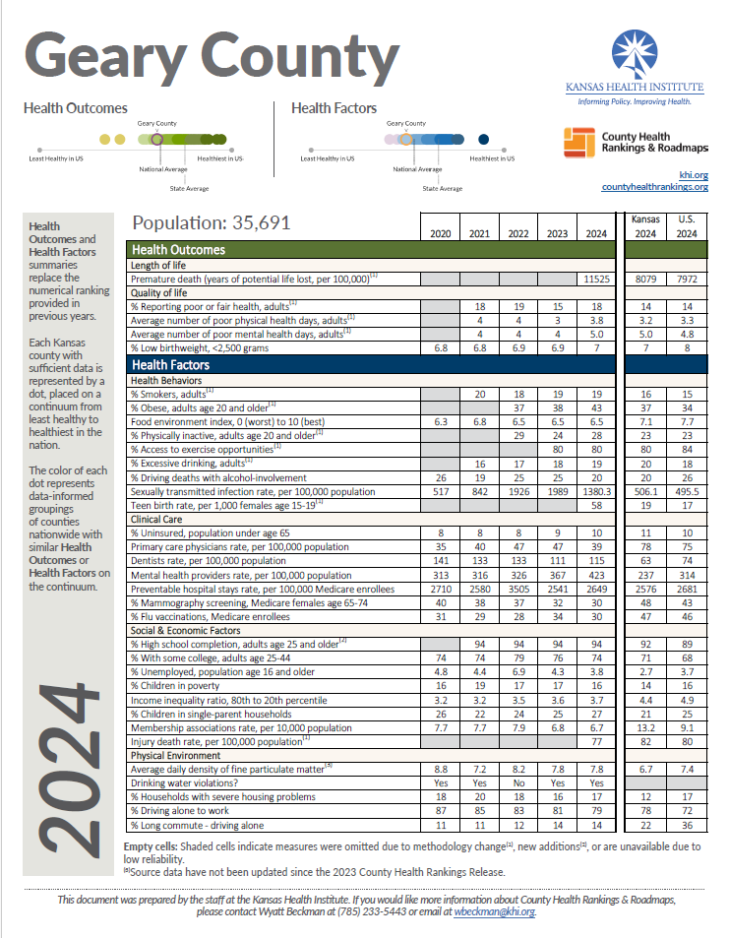

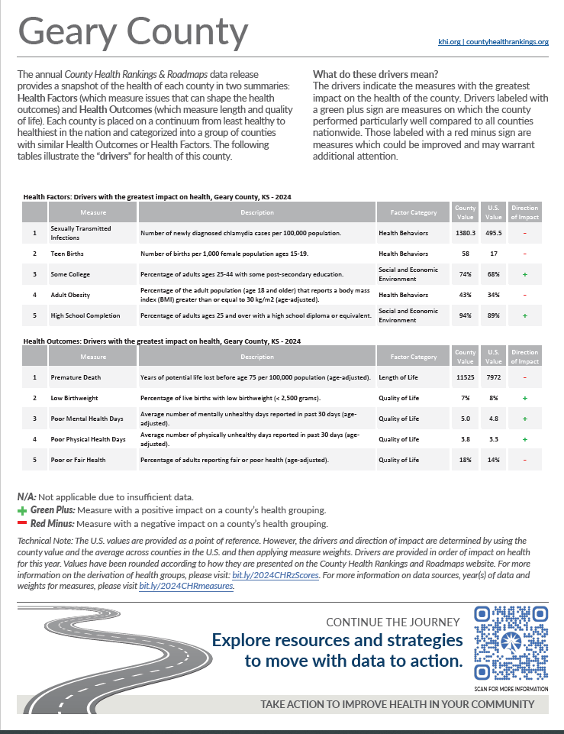

### 4. Town Hall Prioritization Process

The Geary County Town Hall was held May 22, 2024 and attended by 75 stakeholders, representing over 40 organizations. The meeting began with Karla Hedquist and Savanna Gaumer, Stormont Vail Health, reviewing the Community Health Needs Assessment Process and the 2024 CHNA survey results. Viktoria Sterkhova and Kaci Cink, from the Kansas Health Institute provided an overview of the 2024 Geary County Health Rankings. Austin Jackson, Stormont Vail Health & Dr. Reginald Eggleston, USD 475, then led the group in a prioritization exercise. They used the top 10 needs identified by the survey and asked attendees to place the needs on a four-quadrant chart. This exercise allowed the group to decide which needs to focus on for the next CHIP cycle: Access to Community Resources, Youth Character Development, transportation, Obesity, and Mental Health.

### 

Priority Areas Identified at Town Hall:

* Adult Obesity
* Access to Available Community Resources
* Transportation
* Mental Health
* Youth Character Development

**Description of Identified Priority Areas:**

1. **Access to Community Resources**

Access to community resources in Geary County was highlighted as a significant need by the participants of the CHNA survey and roundtable discussions, specifically in our Library children’s time and Fresh Start homeless shelter roundtables. The consensus indicated a demand for more comprehensive and accessible information about available resources and services. At the Fresh Start homeless shelter the participants expressed they prefer resources in printed format, while the moms at Children’s time stated they would prefer a place to find resources and services online. Addressing this diverse preference requires a thoughtful approach. This is particularly crucial for a transient community like Geary County, which frequently sees new residents due to the presence of Fort Riley Army installation. Newcomers often need immediate access to local services to integrate smoothly into the community.

The Dorothy Bramlage Public Library maintains a print resource guide <https://jclib.org/wp-content/uploads/2024/01/Community-Resource-Guide-2024.pdf> and USD 475 maintains a Community Connections resource section on their website <https://www.usd475.org/district-resources/community-connections>. Both of these resources are available to all residents. Resource lists are also compiled kept by individual community health workers and care navigators. Leveraging all of these existing sources will be a helpful starting point when compiling formats that meet the varied needs of the community.

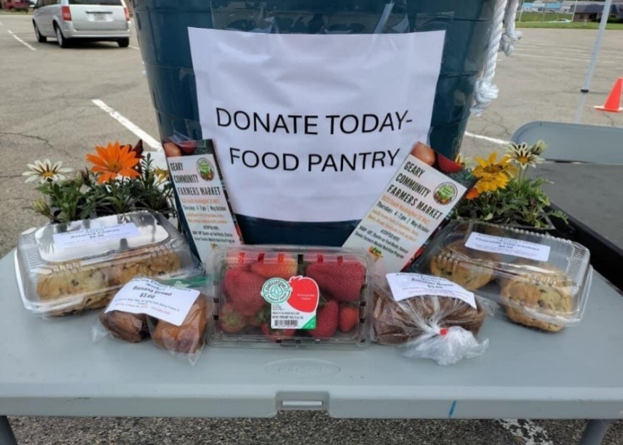

1. **Youth Character Development**

Youth Character Development is vital for the future of Geary County. It lays the foundation for a thriving and resilient community. Engaging young people in meaningful activities helps them build essential life skills, fosters a sense of responsibility, and encourages positive social interactions. There are many local youth character development resources available in the community. Junction City High School contributes significantly, offering Career and Technical Education programs preparing students for career paths and equips them with practical workforce skills. The community also provides numerous opportunities for youth engagement through organizations. These programs offer opportunities for young individuals to explore interests, develop leadership abilities, and contribute to community service projects. Perhaps the identified need is related to increased promotion of available youth character development opportunities.

Currently Available Community Resources:

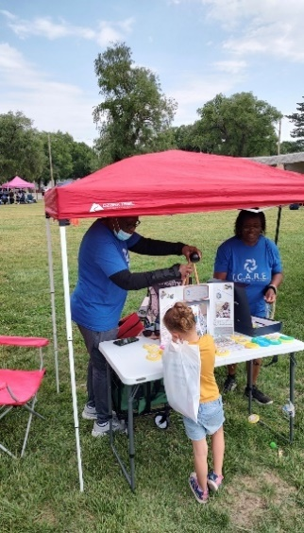Big Brothers/Sisters of Geary Co................ 785-422-9530

Boys & Girls Club of JC/Geary Co. .............. 785-762-4780

Boy Scouts of America (Konza District) ...... 785-587-1818

CASA of the 8th Judicial District.................. 785-762-3907

Child Care Aware of Eastern Kansas .......... 785-357-5171

Child Referral Hotline..................................(877) 678-2548

Community Corrections............................. 785-762-8801

Geary County 4-H....................................... 785-238-4161

Geary County Infant/Toddler Services....... 785-717-4130

Geary Co. Sheriff’s Office Community Involvement Team ......... 785-210-3643

Girls on the Run.......................................... 785-380-7661

Girl Scouts of NE Kansas & NW Missouri ... 800-728-8750

Junction City YMCA.....................................785-762-4780

Kansas Child Abuse Hotline ..................... (800) 922-5330

Kansas Children’s Service League ...............785-274-3100

Kansas Kids@ Gear Up................................785-375-0098

KS Special Healthcare Needs Program (up to age 21) …. 785-296-1313

Kansas Special Olympics/JC Pacesetters.....785-209-1996

Parents as Teachers....................................785-717-6900

Women, Infants, and Children’s Program (WIC)

WIC @ Geary County Health Department 785-240-7019

WIC @ Konza Prairie Community Health Center 785-238-4711, ext. 7001

WIC @ Fort Riley ........785-762-5682

1. **Transportation**

The need for reliable public transportation was identified as a top priority by five of the seven groups participating in the Community Health Needs Assessment Roundtable conversations and was discussed as an underlying factor for several community health concerns during the Town Hall meeting. While the majority of the county’s 36,000 residents live in Junction City, about 13,000 reside in the country and towns of Milford and Grandview Plaza. The community is served by the aTa Bus System from Manhattan but due to availability of funds provides only minimal fixed weekday routes and limited origin to destination on demand response services. No service is available evenings or weekends. Bus routes can be suspended at any time due to staffing or other concerns. Access to food and medical services are major transportation concerns. Populations of focus requiring transportation assistance are the low income and elderly. Since demand response transportation is not readily available, residents without transportation may wait hours for connections to and from medical appointments. Hours of service may also limit access to grocery stores, farmers markets and food distribution locations.

Currently Available Resources:

ATA bus route list: <https://www.fhata.org/_files/ugd/056f4d_e9a7771d54e246f79c3821572b3cbebe.pdf>

BikeWalk JC: <https://www.flinthillsmpo.org/bikewalkjc>

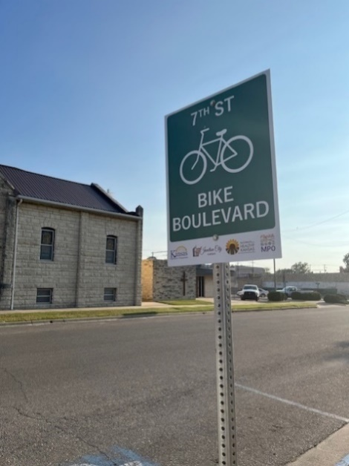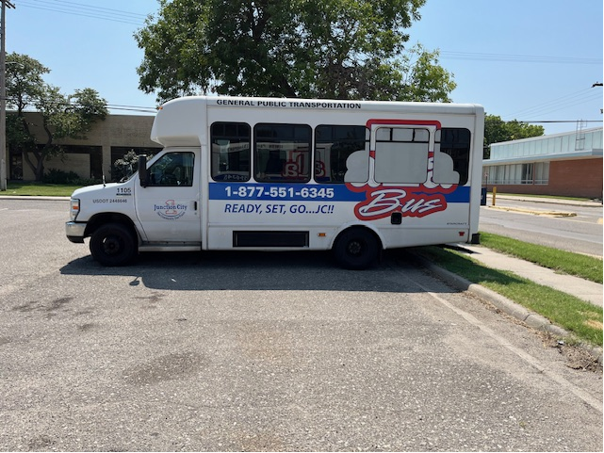

The 7th St. Bike Blvd was installed with grant funds from Blue Cross Blue Shield of Kansas *Pathways to a Healthy Kansas* and Kansas Department of Transportation to provide safer walking and biking for pedestrians and cyclists traveling from downtown to the west side of the City.

1. **Obesity**

Obesity as defined in the County Health Rankings (CHR) is the percentage of the adult population (age 18 and older) that reports a Body Mass Index (BMI) greater than or equal to 30 kg/ m2 age adjusted. 2024 Geary County data indicate a 43% obesity rate, above the Kansas value of 38% and the U.S. value of 34%. The Community Health Needs Assessment survey responses ranked obesity as one of the top 10 concerns. Obesity has been an ongoing concern for local public health agencies. Obesity is directly linked to increased risk for chronic diseases such as diabetes, high blood pressure, heart disease, stroke and some cancers. Factors that influence the obesity rate in Geary County are high food insecurity, and equitable access to healthy food. According the 2024 CHR Geary County’s food environment index rating is 6.5, below Kansas at 7.1 and the U.S. at 7.7. Food Environment Index measures access to healthy foods, accounting for proximity to healthy foods and income. This index considers factors such as the distance an individual lives from a grocery store or supermarket, availability of health food options in the community, and cost barriers to accessing healthy food. Geary County has five identified food deserts (urban residents are more than 1 mile from a full-service grocery store and rural residents are more than 10 miles from a full-service grocery store). Food insecurity may also play a role in obesity. Food Insecurity is defined by the United States Department of Agriculture as the lack of access to enough food for an active, healthy life. Key drivers include unemployment, poverty, and income shocks, which prevent adequate access to food. In 2024, food insecurity in Geary County was 16% according to Feeding America.

Currently Available Resources:

Emergency Food Pantry ............................. 785-238-2156 (Monday & Wednesday 9:30 a.m.-1:30 p.m.)

Food Pantry of Geary County..................... 785-762-8830 (Must complete paperwork prior to pick up)

Wheels of Hope (Mobile service) ............... 785-238-2156

For USD 475 Families.............................. 785-717-4581 (2nd Thursday each month, 4:30-5:30pm)

Geary County Senior Center .................. 785-238-4015 (Monday-Friday 12pm. Homebound delivery available)

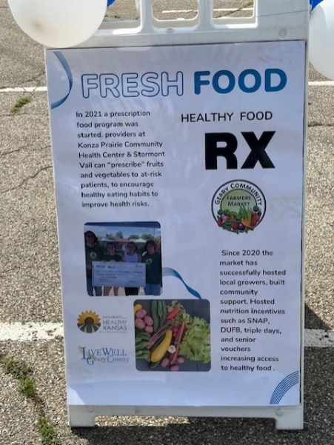

1. **Mental Health**

The need for mental health services across the state of Kansas has increased in the past year. According to the 2023 State of Mental Health Report <https://mhanational.org/sites/default/files/2023-State-of-Mental-Health-in-America-Report.pdf> Kansas ranked 51 in the United States based on high need for mental health services and low access to those services. In the most recent Geary County Community Needs Assessment, mental health was ranked the third highest gap for the community. For Geary County, there is a high population of those in the county that have Tricare due to military employment. Tricare is selective with which therapy licenses they will approve to credential. If a Tricare client sees a non-credentialed therapist for a service, that service will not be covered. A comment in the survey indicated a lack of mental health resources for teenagers. Insurance coverage could be a reason. Another potential reason could be the unwinding of Medicaid in Kansas <https://www.kac.org/report-confirms-the-worst-thousands-of-kids-lost-health-coverage-during-medicaid-unwinding>. During the pandemic, the annual reviews to check continued Medicaid eligibility were waived to allow consumers to continue to have coverage. Since pandemic status was allowed to expire, the Medicaid eligibility reviews have resumed. According to the Kansas Action for Children report, from April 2023 to December 2023 the enrollment numbers for children for Medicaid decreased by nearly 57,000. When those children lose Medicaid coverage, they lose the ability to select which mental health provider they would like to see. Increasing access to mental health services is essential to foster a healthier and more resilient society. Integrating mental health with physical health care create a more inclusive and responsive system. Prioritizing accessibility not only improves individual well-being but also strengthens the overall fabric of our communities, leading to a more productive and compassionate society.

As mental health needs increase so does burnout for mental health providers. The number of

incoming clients outweighs the number of clients that are graduating from mental health services.

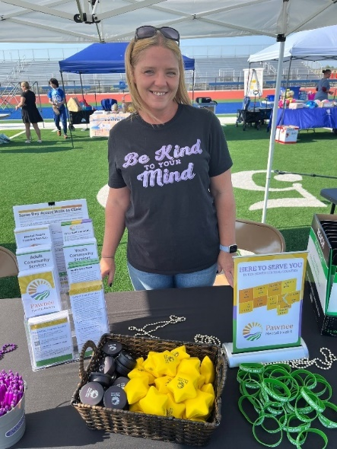

Currently Available Mental Health Resources:

Crisis Center Inc. (domestic & sexual abuse)24-hrs Junction City ...785-762-8835

Family Care Center of Junction City............785-762-4210

Kansas State Family Center ........................785-532-6984

Pawnee Mental Health Services.................785-762-5250

After-hours emergencies ............................ (800) 609-2002

Teen Dating Abuse Hotline...................... (866) 331-9474

Suicide Prevention Hotline (call or text) .....988 (Veterans Crisis Helpline press 1)

Stormont Vail Health Flint Hills Campus ………785-762-2585

Trevor Project (LGBT Youth)…………………..(866) 488-7386

# **Community Profile (A Description of Community Served)**

## **Geary County Kansas**

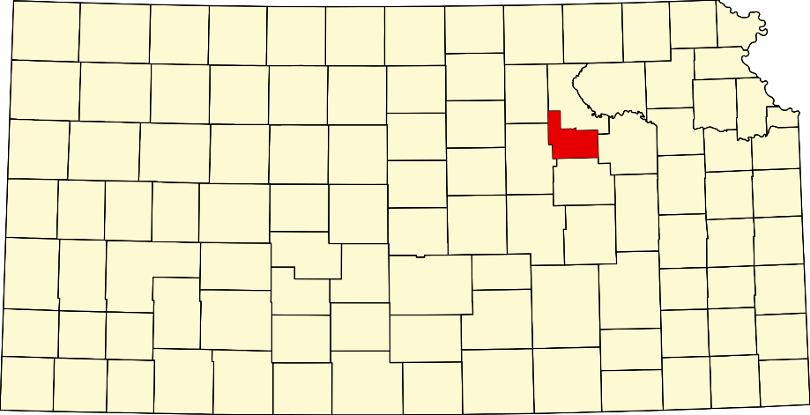

Geary County is located in North Central Kansas and includes a portion of the Fort Riley Army installation. The county covers approximately 1,166 square miles and has a mix of rural and urban areas. It features a variety of outdoor recreational opportunities, including parks and natural areas. It is part of the Manhattan Metropolitan Statistical Area. The county seat is Junction City, which is the largest city in the county. Geary is one of the few Kansas counties where a single school district, USD 475, serves the entire county.

Before European settlers arrived, the area was inhabited by Native American tribes, including the Kansa and Osage peoples. The region began to see European settlement in the mid-19th century as part of the westward expansion of the United States. A major chapter in Geary County's history began with the establishment of Fort Riley in 1853. The fort was strategically located to protect travelers and settlers moving west along the Oregon Trail and to support the U.S. military's operations in the region. Fort Riley played a significant role during the Indian Wars, the Civil War, and later conflicts. During the American Civil War, Fort Riley served as a training and staging area for Union troops. In the subsequent Indian Wars, it was a key military post in efforts to secure the plains and manage relations with Native American tribes. In the late 19th and early 20th centuries, the presence of Fort Riley and the expansion of the railroad network contributed to the growth of Junction City and the surrounding areas. Agriculture, especially cattle ranching and farming, became important economic activities in the region.

Today, Geary County continues to be influenced by Fort Riley, which remains a major military installation, contributing to the local economy and community life. The county also maintains its historical heritage through various museums and historical sites that preserve its rich past.

## 

## Demographic Profile

Understanding population and household makeup is vital in CHNA evaluation. Data shows a population that is highly mobile and significant issues with poverty, especially children in poverty. Median Household income is 84% of the Kansas average.

|  |  |  |  |
| --- | --- | --- | --- |
| **Demographic Indicator** | **Geary Co KS** | **State of KS** | **Source** |
| Population estimates, July 1, 2020 | 36,739 | 2,937,880 | U.S. Census |
| Median Age | 26.6 | 37.6 | U.S. Census |
| Employment Rate | 51.4% | 62.5% | U.S. Census |
| Total Employer Establishments | 582 | 75,057 | U.S. Census |
| Median Household Income | $57,992 | $68,925 | U.S. Census |
| Total Housing Units | 15,928 | 1,275,689 | U.S. Census |
| Residents with Bachelor’s Degrees or Higher (%) | 23.8% | 35.6% | 2022 American Community Survey |
| Residents without Health Care Coverage (%) | 7.7% | 8.6% | 2022 American Community Survey |
| Residents reporting Hispanic or Latino Ethnicity | 5,776 | 382,603 | 2022 American Community Survey |
| Residential Mobility in the last year. | 39.9% | 14.6% | 2022 American Community Survey |
| % of residents who travel alone to work | 78.6% | 75.3% | 2022 American Community Survey |
| Children in poverty, % | 28.6% | 14% | U.S. Census |
| High School Graduate or higher, % of persons age 25+ yrs. 2022, 1 year estimate | 93.8% | 91% | 2022 American Community Survey |
| School Enrollment, K-12 | 64.1% | 68.3% | 2022 American Community Survey |

## Trends in Health Indicators Show Worsening Health Status in Geary County

Based on health indicators provided by Kansas Health Matters, the trend for overall health status of Geary County is negative. In particular, heart disease mortality and overall mortality moved in a negative direction. Of particular note, however, is the lower rate of infant mortality compared to state average and prior reporting period. This shows a commitment by the community to improve the health outcomes of infants and mothers after identifying the concern during previous Community Health Needs Assessments.

|  |  |  |  |  |
| --- | --- | --- | --- | --- |
| **Health Indicators** | **Trend** | **Geary Co KS** | **Prior Value (previous measurement period)** | **State of KS** |
| Percent of Adults who are Overweight |  | 32.1% | 33.1% | 34.4% |
| STI rate (Cases per 1000) |  | 9.0 | 15.1 | 6.1 |
| Infant Mortality (per 1000 live births) |  | 5.6 | 5.7 | 5.9 |
| Low Birth Weight, % of total live births |  | 8.4% | 7.9% | 7.5% |
| Age Adjusted Mortality per 100,000 population- Overall |  | 1081.6 | 1056.3 | 878.9 |
| Age Adjusted Mortality per 100,000 population- Heart Disease |  | 251.9 | 254.8 | 170.4 |
| Age Adjusted Mortality per 100,000 population- Suicide |  | 32.1 | 32.5 | 19.3 |
| Uninsured Population |  | 12.6% | 11.4% | 13.4% |

Health System Patient Draw

The vast majority of patients receiving care at Stormont Vail Health facilities reside in Geary County. As such, Stormont Vail engaged in CHNA efforts focused on needs expressed by Geary County residents. This is the first opportunity for Stormont Vail Health to participate and lead to the Community Health Needs Assessment process for Geary County as SVH acquired the former Geary Community Hospital in January of 2023.

|  |  |  |  |  |
| --- | --- | --- | --- | --- |
| Unique Patients by county of residence at time of service | % of Total | | Unique Patients Served | |
| County of residence | FY 2023 | FY 2024 | FY 2023 | FY 2024 |
| Geary | 79.1% | 77.2% | 12,822 | 14,334 |
| Dickinson | 11.0% | 11.7% | 1,777 | 2,168 |
| Riley | 9.6% | 10.4% | 1,554 | 1,927 |
| Shawnee | 2.8% | 2.9% | 456 | 536 |
| Clay | 2.0% | 1.9% | 331 | 352 |
| Morris | 2.1% | 2.2% | 346 | 406 |
| Pottawatomie | 1.4% | 1.6% | 219 | 297 |
| Others (468 Counties) | 12.7% | 12.6% | 2,049 | 2,349 |
| Total | 100% | 100% | 16,203 | 18,578 |
| Patients may move between different service dates. The county shown is at the date of service. FY2024 is through July 31. | | | | |

**2023 Age Distribution** Junction City Geary County Economic Development Commission

Ages 0 to 9 - 7224

Ages 10 to 19 - 4044

Ages 20 to 29 - 8807

Ages 30 to 39 - 6351

Ages 40 to 49 - 3204

Ages 50 to 59 - 2141

Ages 60 to 64 - 970

Ages 65+ = 3132

**Languages Spoken**  *[2022 American Community Survey 5-Year Estimates](https://www.census.gov/programs-surveys/acs.html)*

**16.2%** Language other than English spoken at home compared to **11.7%** in Kansas

English only - 83.8%

Spanish - 9.8%

Asian and Pacific Islander languages 2.5%

3.1% Other languages

**Homeownership Rate** *2022 American Community Survey 5-Year Estimates*

**43.0%** Homeownership Rate in Geary County, Kansas vs **67.7%** Homeownership Rate in Kansas

12.1% Moved from abroad vs 3.4% in Kansas

**Veterans** [*2022 American Community Survey 5-Year Estimates*](https://www.census.gov/programs-surveys/acs.html)

**22.4%** Veterans in Geary County, Kansas vs **6.9%** Veterans in Kansas (Male - 79.6% and Female - 20.4%)

**Poverty** [*2022 American Community Survey 5-Year Estimates*](https://www.census.gov/programs-surveys/acs.html)

Estimate for Poverty, all people in Geary County, Kansas. **18.6%. vs. 12%** all people in Kansas

Under 18 years - 28.6%

18 to 64 years - 14.7%

65 years and over - 8.9%

**Crime** Bestplaces.net

Crime is ranked on a scale of 1 (low crime) to 100 (high crime)

Geary County violent crime is 22.4. (The US average is 22.7)

Geary County property crime is 30.4. (The US average is 35.4)

**Workforce Classification** *2022 American Community Survey 5-Year Estimates*

**30.7%** Local, state, and federal government workers in Geary County, Kansas vs **16.3%** in Kansas

Employee of private company workers - 57.3%

Self-employed in own incorporated business workers - 0.9%

Private not-for-profit wage and salary workers - 4.8%

Local, state, and federal government workers - 30.7%

Self-employed in own not incorporated business workers and unpaid family workers - 6.2%

**Labor Force** Junction City Geary County Economic Development Commission

Geary County has a labor force of 17,881 people, with an unemployment rate of 3.5%.

62.59% of businesses have 1-4 employees

18.29% have 5-9 employees

9.98% have 10-19 employees

4.04% have 20-49 employees

3.56% have 50-99 employees

1.55% have 100+ employees

**Industry for the Civilian Employed Population 16 Years +** [*2022 American Comm Survey 5-Year Estimates*](https://www.census.gov/programs-surveys/acs.html)

Agriculture, forestry, fishing and hunting, and mining - 1.0%

Construction - 6.6%

Manufacturing - 7.7%

Wholesale trade - 2.7%

Retail trade - 15.3%

Transportation and warehousing, and utilities - 4.3%

Information - 1.2%

Finance and insurance, and real estate and rental and leasing - 5.0%

Professional, scientific, management- and administrative and waste management services - 7.1%

Educational services, health care and social assistance - 23.5%

Arts, entertainment, recreation, accommodation and food services - 9.5%

Other services, except public administration - 5.5%

Public administration - 10.7%

**Major Civilian Employers**

City of Junction City

Eagle Railcar

Foot Locker

Fort Riley Civilian Personnel Office

Geary County

Kaw Valley Engineering

Konza Prairie Community Health Center

Michelin

New Horizons RV

Smithfield Foods

Stormont Vail Health

Superior Products

UPU Industries

USD 475

**Conclusion and Next Steps:**

### While the completion of the CHNA is a significant achievement and should be celebrated, the CHNA is not designed to be a report that is created and then stands alone. With the CHNA now completed for this cycle, work as a community continues almost immediately to make impacts on current priorities and inform the decision-making around updating strategies through the health improvement planning process. The CHIP and the inspiration behind its creation is to develop a living document that serves as the platform for developing collective impact principles that focus on priorities that we determined through our comprehensive CHNA process; ultimately providing our community with a strategic roadmap to eliminating health disparities and improving health outcomes.

Given the data gathered during the Roundtables, Survey, and Town Hall discussions, Geary County has a clear line of sight to the work ahead of us. The community has spoken clearly about the top five areas of need: Access to Community Resources, Youth Character development, Transportation, Obesity, and Mental Health. While these topics are not small in scale by any means, they are the correct work in which the community needs to engage to achieve healthier outcomes.

Starting in the last quarter of 2024 and into 2025, the community will now enter into a Community Health Improvement Plan (CHIP) development process, focused on creating actionable and specific interventions targeted at these areas of identified need. The CHIP will be drafted in detail to add specific objectives, strategies, timeframes, assignments and workplans required to meet the corresponding goals and objectives. For the dedicated organizations of the Geary County community that engage in this health improvement work, led by Live Well Geary County Coalition and other organizations, this will entail a commitment to work collaboratively to achieve a collective impact on the strategies outlined within the CHIP.

If you would like to participate in this important work, please contact Susan Jagerson at: [livewellgearycounty@gmail.com](mailto:livewellgearycounty@gmail.com)

**Appendix**

**Appendix I- Full Survey**

**2024 Community Health Needs Assessment**

**General Information**

1. Do you live in Geary County?  Yes  No {Ends the survey if not in Geary County}
2. What is the ZIP code of your home address? 66441 66442 66514

**Health Care**

1. Where do you USUALLY go, when you or members of your household need basic, NON-EMERGENCY medical care? (Mark only one.)

|  |  |  |
| --- | --- | --- |
| Did not seek medical care | Emergency department | Immediate/ Express care |
| Nonprofit Community clinic (Konza) | Private clinics (Blue River, Stone Creek, SVH rural health clinic) | Personal/private doctor (BlueFire, Dr. Lochamy) |
| Other: Specify | Retail Provider (Amazon, Walmart, CVS) | Geary Co. Health Dept. | |

1. Is everyone in your household covered by health insurance? Yes No if no, why (Too expensive, work doesn’t offer, etc.)
   1. If YES: What types of coverage do you have? (Mark all that apply.)

|  |  |  |
| --- | --- | --- |
| Medicaid | Tricare | Other: (Specify: ___) |
| Medicare | Private insurance (Blue Cross Blue Shield, etc.) | |

1. In the past 12 months, did you or anyone in your household need any of the following services:

|  |  |  |  |  |  |
| --- | --- | --- | --- | --- | --- |
| Counseling – behavioral/mental healthcare | Yes | No | If YES, was that care received? | Yes | No |
| Dental care | Yes | No | Yes | No |
| Medical care | Yes | No | Yes | No |
| Prenatal care | Yes | No | Yes | No |
| Quitting tobacco/nicotine | Yes | No | Yes | No |
| Substance/opioid use care | Yes | No | Yes | No |
| Prescription Medication | Yes | No |  | Yes | No |

If you did not receive care, why not?

☐Care was not available ☐Care was too expensive ☐Did not seek care

☐ My language was not available. ☐Lack of transportation ☐Other: (Specify ___)

1. For each of the following health procedures, please indicate the last time you yourself had the procedure done.

|  |  |  |  |  |  |
| --- | --- | --- | --- | --- | --- |
|  | In the past 12 months | In the last 1-5 years | More than 5 years ago | Never | Not applicable |
| Blood pressure check |  |  |  |  |  |
| Dental screening |  |  |  |  |  |
| Flu vaccine |  |  |  |  |  |
| COVID vaccine |  |  |  |  |  |
| Mammogram |  |  |  |  |  |
| Pap smear |  |  |  |  |  |
| Prostate exam |  |  |  |  |  |

1. For each concern listed below, please share if - in the past 12 months - it has been a major concern, a moderate concern, a minor concern, or not a concern for your household.

|  |  |  |  |  |  |  |  |
| --- | --- | --- | --- | --- | --- | --- | --- |
| # | Health or Social Concerns | Major Concern | Moderate Concern | Minor Concern | Not a Concern | Don’t Know | Was unavailable |
| 1 | Access to fresh fruits and vegetables |  |  |  |  |  |  |
| 2 | Physical activity opportunities |  |  |  |  |  |  |
| 3 | Access to voting |  |  |  |  |  |  |
| 4 | Adult basic education (job skills, computers, literacy, etc.) |  |  |  |  |  |  |
| 5 | Adult day care services |  |  |  |  |  |  |
| 6 | Assistance to active military |  |  |  |  |  |  |
| 7 | Assistance to military dependents |  |  |  |  |  |  |
| 8 | Assistance to military veterans |  |  |  |  |  |  |
| 9 | Before/after school services |  |  |  |  |  |  |
| 10 | Bullying |  |  |  |  |  |  |
| 11 | Commercial Tobacco Use |  |  |  |  |  |  |
| 12 | Up to date information about available community services |  |  |  |  |  |  |
| 13 | Disaster response including shelter |  |  |  |  |  |  |
| 14 | Domestic/family violence |  |  |  |  |  |  |
| 15 | Environmental pollution/recycling |  |  |  |  |  |  |
| 16 | Financial assistance (housing/utility) |  |  |  |  |  |  |
| 17 | Financial assistance (medical, dental, behavioral health care) |  |  |  |  |  |  |
| 18 | Financial/credit counseling (Including housing) |  |  |  |  |  |  |
| 19 | Food assistance |  |  |  |  |  |  |
| 20 | Home repair/safety |  |  |  |  |  |  |
| 21 | Home/meal delivery services for homebound individuals |  |  |  |  |  |  |
| 22 | Homelessness |  |  |  |  |  |  |
| 23 | Human/sex trafficking |  |  |  |  |  |  |
| 24 | Immunizations (both adult and child) |  |  |  |  |  |  |
| 25 | Infant/child care, including daycare |  |  |  |  |  |  |
| 26 | Injury prevention devices (bike helmets, etc.) |  |  |  |  |  |  |
| 27 | Job training/retraining assistance |  |  |  |  |  |  |
| 28 | Juvenile delinquency |  |  |  |  |  |  |
| 29 | Gang activity |  |  |  |  |  |  |
| 30 | Legal assistance |  |  |  |  |  |  |
| 31 | Mental Health Concerns (Depression/ Anxiety) |  |  |  |  |  |  |
| 32 | Mentoring for children/youth |  |  |  |  |  |  |
| 33 | Child Obesity |  |  |  |  |  |  |
| 34 | Adult Obesity |  |  |  |  |  |  |
| 35 | Neighborhood Safety |  |  |  |  |  |  |
| 36 | Support to transition into community |  |  |  |  |  |  |
| # | Health or Social Concerns | Major Concern | Moderate Concern | Minor Concern | Not a Concern | Don’t Know | Was unavailable |
| 37 | Opportunities for social interaction |  |  |  |  |  |  |
| 38 | Parenting education/support |  |  |  |  |  |  |
| 39 | Care while Pregnant |  |  |  |  |  |  |
| 40 | Resources for caregivers |  |  |  |  |  |  |
| 41 | Safe, affordable, accessible housing |  |  |  |  |  |  |
| 42 | Sexual assault |  |  |  |  |  |  |
| 43 | Student classroom attendance |  |  |  |  |  |  |
| 44 | Substance use (i.e. opioid, alcohol) |  |  |  |  |  |  |
| 45 | Enough options for healthy eating |  |  |  |  |  |  |
| 46 | Treatment for Chronic Conditions (i.e. Diabetes) |  |  |  |  |  |  |
| 47 | Tutoring for children/youth |  |  |  |  |  |  |
| 48 | Accidental injuries (falls, etc.) |  |  |  |  |  |  |
| 49 | Unplanned pregnancy |  |  |  |  |  |  |
| 50 | Vaping |  |  |  |  |  |  |
| 51 | Youth development/character building programs |  |  |  |  |  |  |

**Income and Support**

1. Are you currently employed?

Yes, full-time  Yes, part-time  No

* 1. If NO: Are you:  Disabled  Family Manager/Stay-At Home  Retired Student  Unemployed

1. In the past 12 months, has anyone in your household been laid off from any job due to the economy and/or workforce reduction? Yes  No

OTHER CONCERNS of importance to you in the past 12 months:

1.

2.

3.

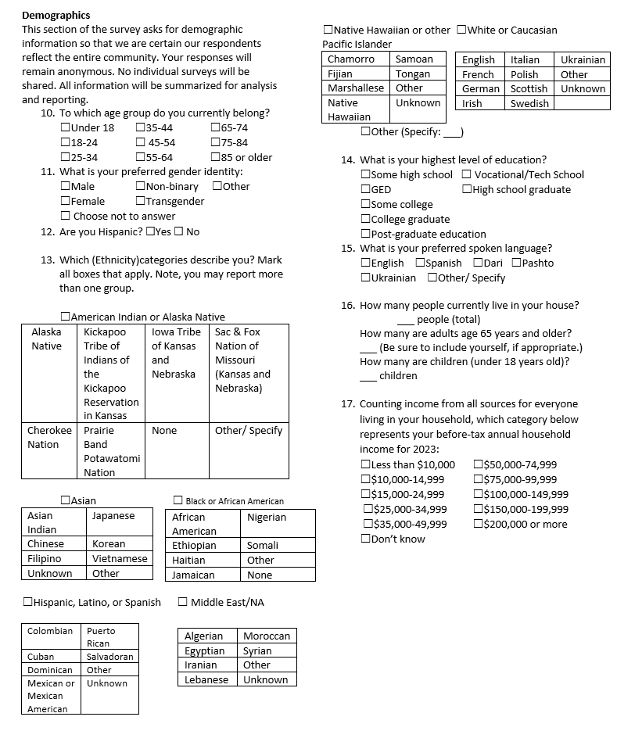

**Appendix II- Primary Care Services Available in Geary County**

* Stormont Vail Health Flint Hills Campus
  + 1102 St. Mary’s Rd, Junction City, KS 66441
  + 785-762-2585
* Konza Prairie Community Health Center
  + 361 Grant Ave, Junction City, KS 66441
  + 785-238-4711
* Dr. Richard Lochamy, MD
  + 327 E. Chestnut St, Junction City, KS 66441
  + 785-762-6543
* Junction City VA Clinic
  + 623 Southwind Dr, Junction City, KS 66441
  + 800-574-8387

**Appendix III-Roundtable Discussion Slide Deck**

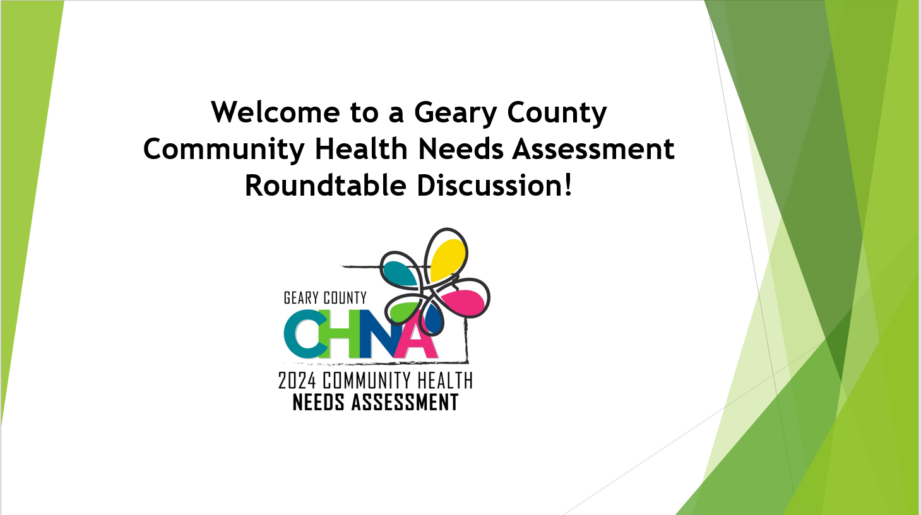



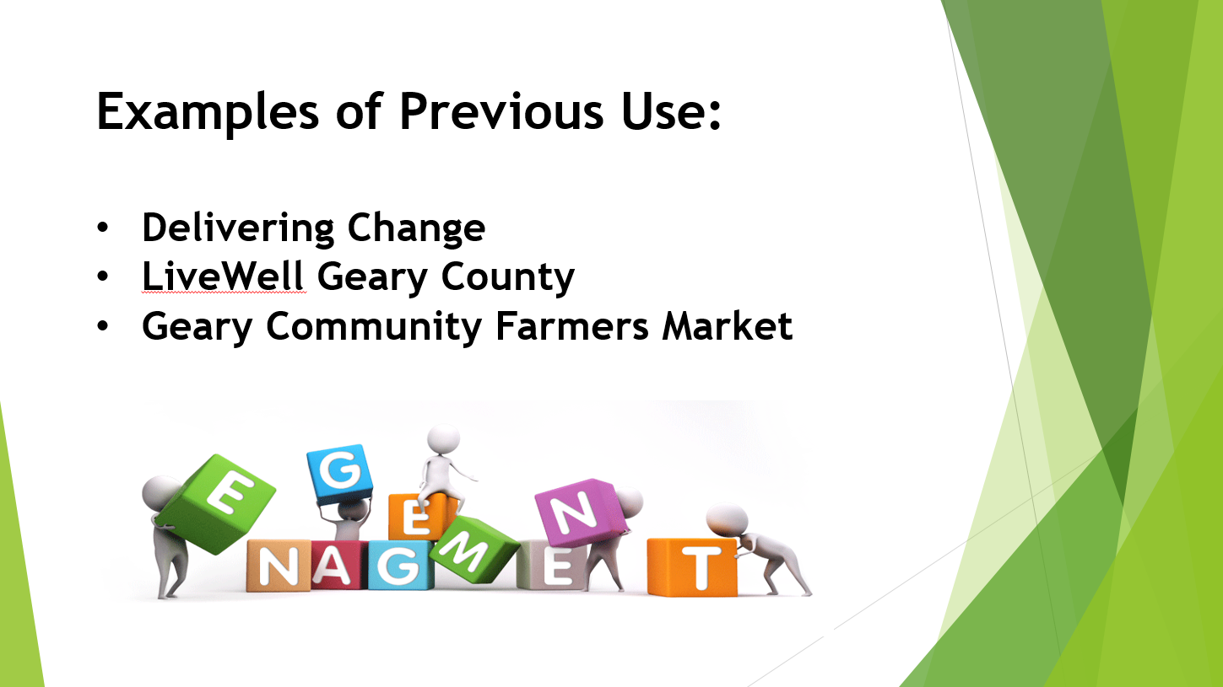

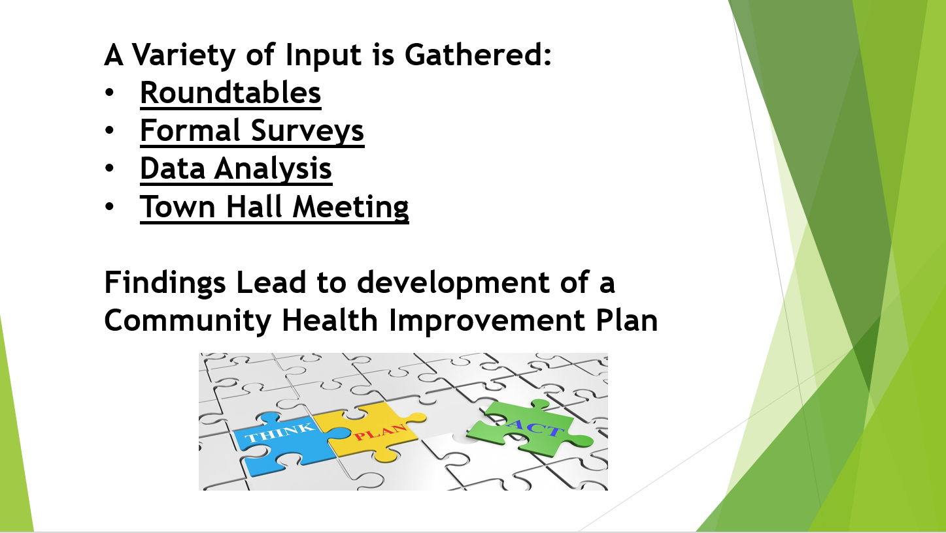

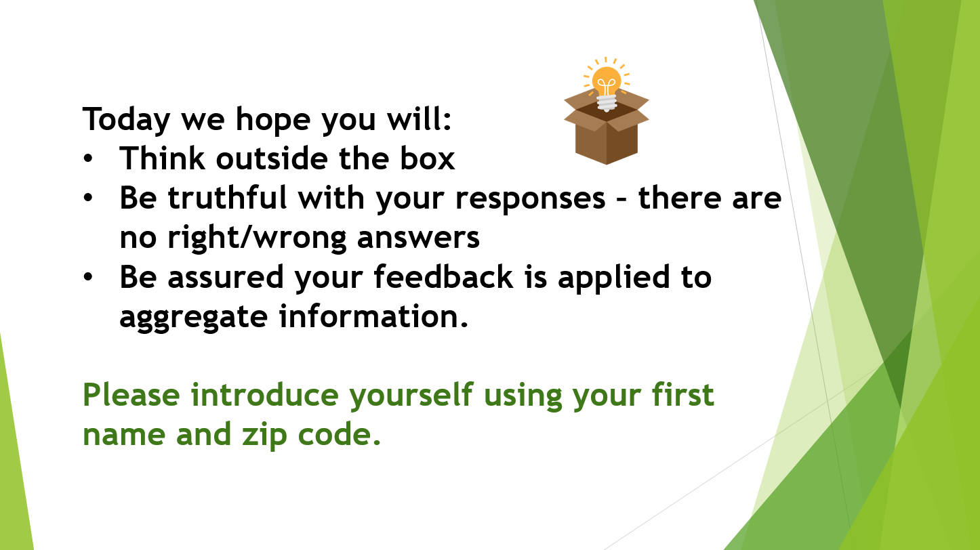

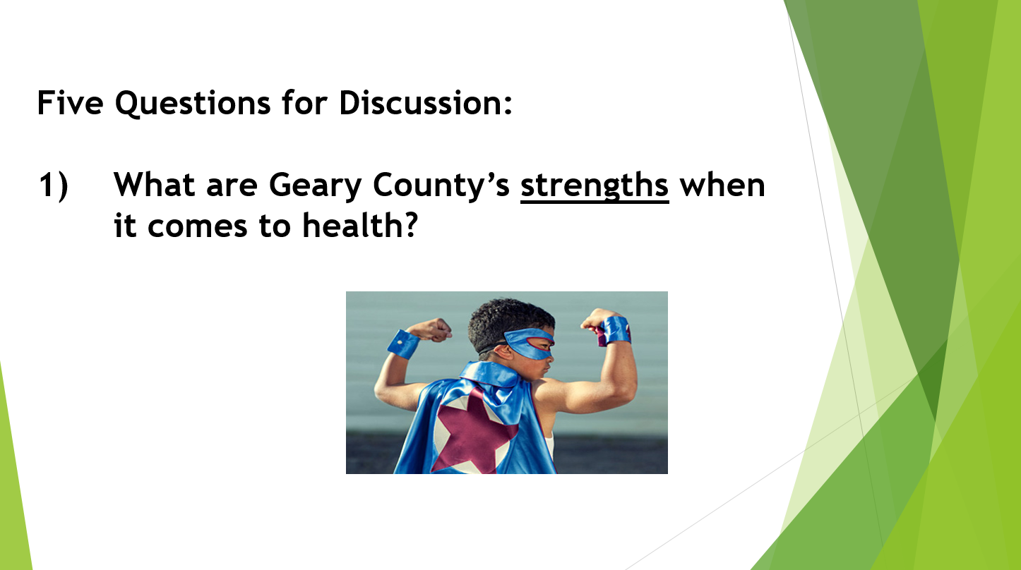

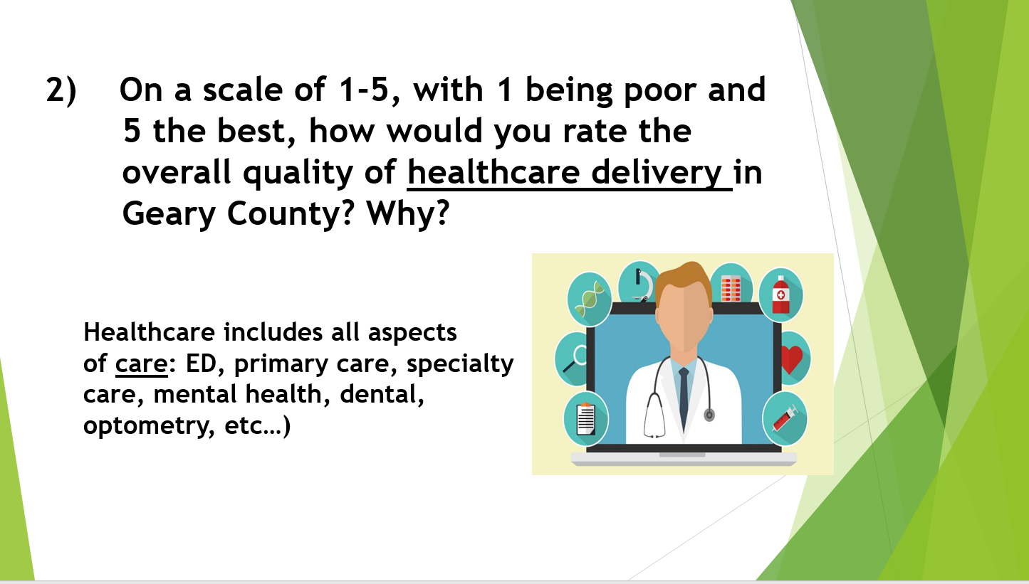

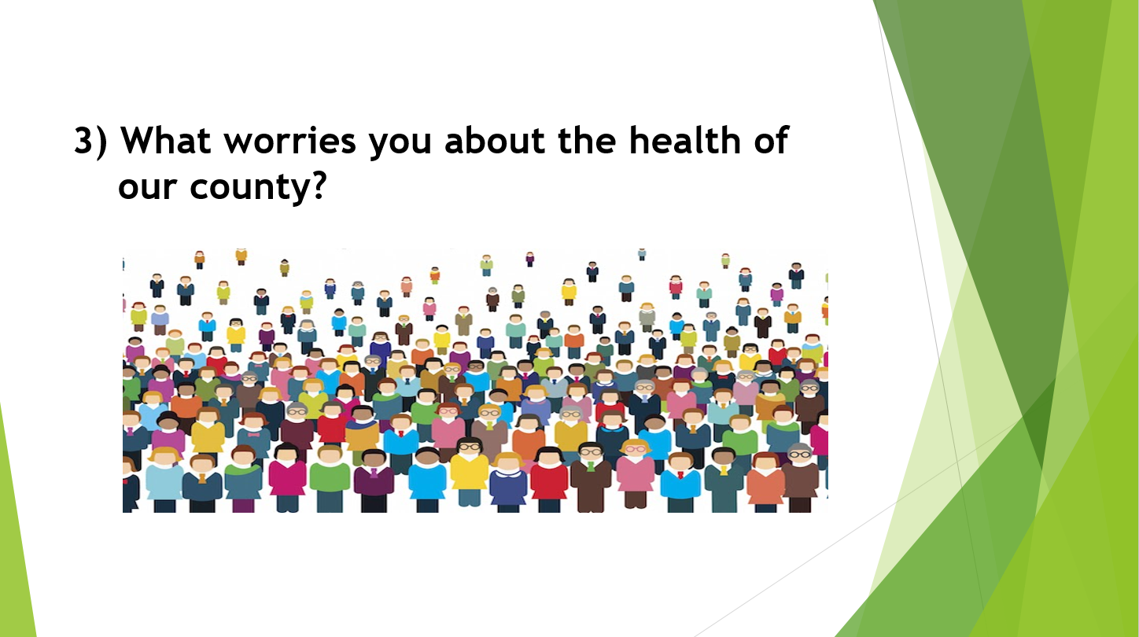

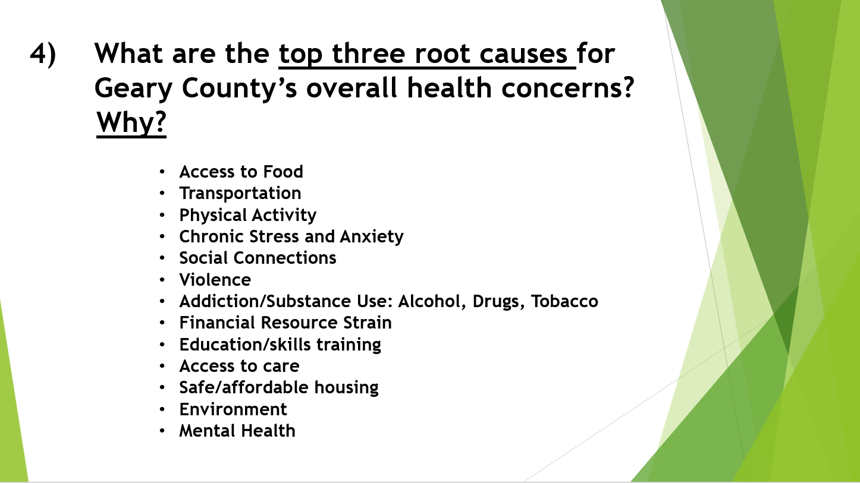

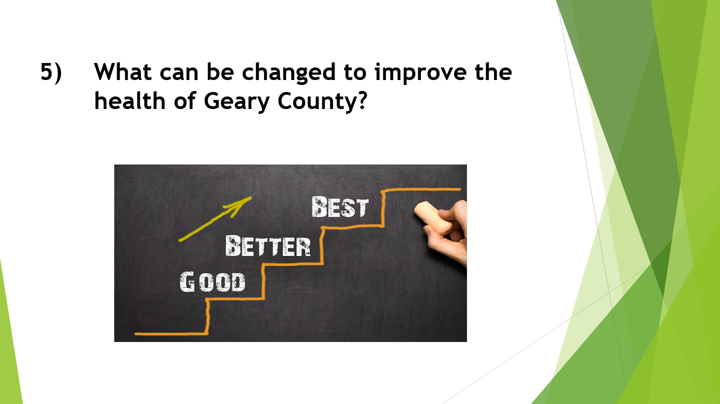

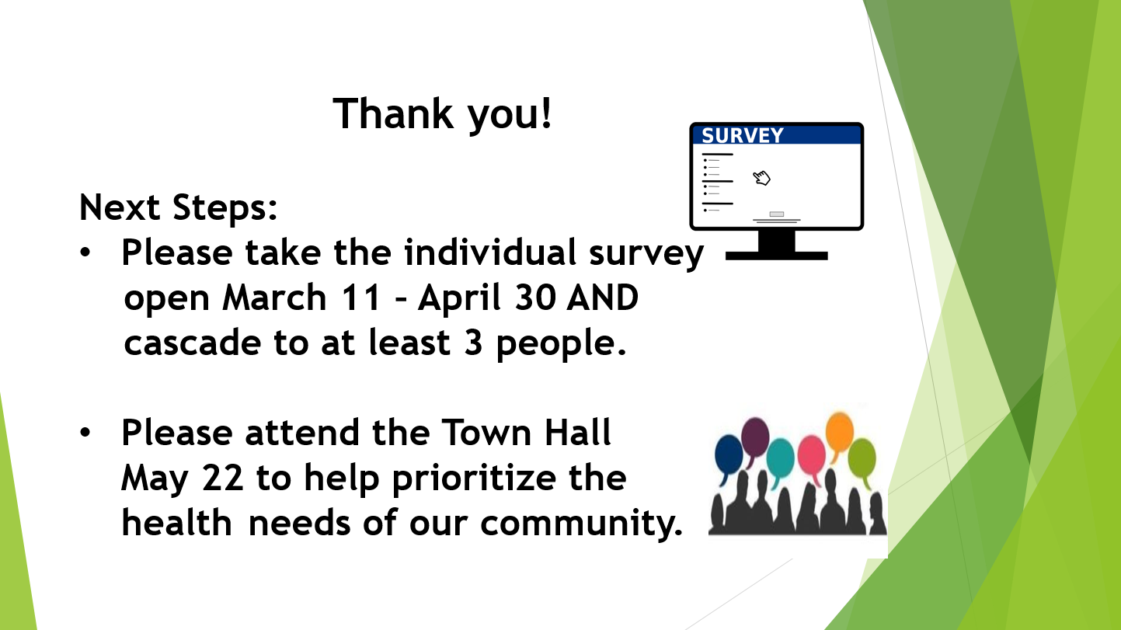

**Appendix IV- Steering Committee Member Organizational Profiles**

**Stormont Vail Health**

**Mission**

“Working together to improve the health of our community”

**Vision**

Stormont Vail Health will be a national leader in providing compassionate, high-quality and efficient integrated care through collaboration that results in a healthier community.

Stormont Vail Health has been committed to the communities we serve and to Kansas, providing the best possible health care for more than 130 years. Stormont Vail Hospital is the product of the 1949 merger between Christ’s Hospital (Opened in 1884) and the Jane C. Stormont Hospital and Training School for Nurses (1895). Stormont Vail Hospital and Cotton O’Neil joined in 1995 to form Stormont Vail Health.

Stormont Vail is a nonprofit integrated health care system based in Topeka, Kansas, serving a multicounty region in northeast Kansas. With hospital campuses in Topeka and Junction City and multiple clinics across the region, Stormont Vail Health employs more than 500 providers and 5,700 team members. Stormont Vail has been recognized as a Magnet organization by the American Nurses Credentialing Center since 2009 for excellence in nursing services. Stormont Vail Health is proud to be a member of the Mayo Clinic Care Network and partner with Children’s Mercy Topeka. Stormont Vail has the region’s only Level III Neonatal Intensive Care and only verified trauma center.

Stormont Vail Health takes a holistic approach to providing care. We understand that health care goes beyond treating physical and mental ailments. That’s why we provide our patients with vital connections to the community that help them learn, grow, and heal.

Every interaction with our patients, their families and our co-workers is an opportunity to leave a memorable, positive impact on their lives. A small moment, whether big or small, collectively shape who we are as a health care organization rooted in the communities we serve.

**Pawnee Mental Health**

**Mission**

At Pawnee Mental Health we are committed to enhancing the well-being of individuals and families in our community through a holistic approach to behavioral health and recovery services. Our mission is to provide compassionate, person-centered care that fosters healing, empowerment, and resilience.

**Vision**

We envision a community where mental health and substance use challenges no longer carry a stigma and where individuals can access the support they need to live fulfilling, meaningful lives. We aspire to be a beacon of hope, resilience, and recovery in our community, fostering positive change that ripples outward to touch the lives of all those we serve.

At Pawnee Mental Health, we are more than a mental health and recovery services provider; we are a partner on your journey toward healing, self-discovery, and empowerment. Together, we will build a healthier, happier, and more vibrant community, one person at a time.

**About**

Founded in 1956, Pawnee Mental Health is a private, not-for-profit Community Mental Health Center (CMHC) and Certified Community Behavioral Health Clinic (CCBHC). This designation enhances the organization's ability to serve the community comprehensively, ensuring that individuals receive whole-person care at the right time. Pawnee provides a full range of mental health, substance use recovery, and crisis services for residents of 10 north central Kansas counties. Approximately 7,000 adults, adolescents, and children are served annually.

At Pawnee Mental Health, our values reflect our unwavering commitment to the well-being of every individual we serve. We lead compassionately, approaching each person with empathy, understanding, and a non-judgmental attitude, believing in their inherent worth and potential. Collaboration is at the heart of our work; we partner closely with our clients, their support systems, and the community to craft personalized treatment plans that cater to their unique needs, goals, and aspirations. We empower individuals to take an active role in their recovery by equipping them with the knowledge, skills, and support necessary for making positive, lasting changes in their lives.

Our approach to care is holistic, recognizing the vital connections between physical, emotional, and spiritual well-being. We offer a broad spectrum of services ranging from counseling and therapy to wellness and self-care practices designed to support overall health. Inclusivity is a cornerstone of our organization, as we embrace diversity and are dedicated to creating a safe and welcoming environment for all, regardless of background, identity, or life circumstances. Finally, we uphold the highest quality standards in our services, ensuring they are evidence-based, effective, and accountable to those we serve.

**Live Well Geary County**

**About**

The Access to Healthy Food Coalition was formed in 2015 through a National WIC Association grant and officially incorporated as the 501 c3 non-profit organization, Live Well Geary County, in 2016. A Community Health Assessment (CHA) showed the need for a county-wide coordinated action among health and wellness stakeholders to address food insecurity and other health issues.   LWGC Coalition was organized to inspire and advance policy, systems, and environmental changes that make it easier for Geary County residents to lead healthier lives.

**Purpose**

The purpose of the coalition is to develop short and long-term community goals to improve community health, align and coordinate member efforts so that they are mutually reinforcing, inform the public about issues related to the health of the community, and mobilize public support for changes that support improved community health and wellness. LWGC is developing dynamic, community-based strategies to improve the health of community residents. A Phase 1 and Phase 2 Blue Cross Blue Shield of Kansas *Pathways to a Healthy Kansas* grant recipient LWGC focuses on the social determinants of health through initiatives aimed at improving access to healthy food, increasing opportunities for active living, and commercial tobacco cessation and prevention.

**Konza Prairie Community Health Center**

**Mission**

“Affordable, quality, comprehensive medical, dental, and behavioral healthcare for all in a courteous, professional, and personalized manner.”

**About**

Founded in Junction City, Konza Prairie Community Health Center has served the Flint Hills region for nearly 30 years and is part of a nationwide network of 1,400 Federally Qualified Health Centers which serve more than 31 million people across the country. Community health centers have their roots in the Civil Rights Movement of the 1960’s. The founding community activists and reform-minded physicians who established the earliest health centers believed that we could fight poverty and empower communities with healthcare and opportunity.

Konza’s locally owned not-for-profit clinics in Junction City, Manhattan, and Chapman provide comprehensive medical services, full-scope dental services, integrated behavioral health care and low-cost pharmacy services to more than 13,000 patients from 12 counties in northeast Kansas. Our clinics employ more than 130 providers and staff from throughout the region.

At Konza, we believe access to quality, affordable healthcare is a fundamental right. On any given day, you will find in our lobbies business leaders, elected officials, military retirees, and patients experiencing homelessness, low-income families, single mothers, and refugees – all accessing the same high-quality providers and services, regardless of income or insurance status.

We recognize that the healthcare system is challenging, at best, and nearly impossible to navigate for those who are underserved. More than 70% of our patients earn below 200% of Federal Poverty Guidelines, so Konza goes beyond healthcare to provide direct, on-site support services to provide food, clothing, and personal hygiene items, and connect patients with social service benefits, community housing and food resources.

As a community health center, Konza is held to the highest standards of care. In 2023, we earned national recognition among our peers as a Health Center Quality Leader, ranking us among the top third of community health centers in the country for best overall clinical performance.

Our team of dedicated providers and support staff work alongside like-minded community partners to strive for health equity and empower the communities we serve, until we realize our mission of healthcare for all.

**USD 475**

**Vision**

Our vision for Geary County Schools USD 475 is to become a high-performance school district where students are the top priority.

**Mission**

Our mission is to prepare today’s students for tomorrow’s world.

**Values**

**Students First:** At Geary County Schools, students are our No. 1 priority. Academic and socially responsive actions will be in the best interests of the students.

**Integrity:** We expect each individual, whether student or faculty, to do what is right despite self-interest.

**Respect:** Valuing the collaborative contributions of others is essential in the progression of our team and culture at Geary County Schools.

**Accountability:** Each individual is expected to own the problem/situation or task and take the necessary actions to improve or correct it.

**Positivity:** The power of positivity is severely underrated but here at Geary County Schools, we strive to adopt an optimistic outlook and influence throughout our daily interactions and community.

**Fiscally Responsible:** Allocation of resources in alignment with the district mission.

**Process to Provide Feedback on CHNA**

If you would like to provide feedback on the 2024 Geary County Community Health Needs Assessment, please contact:

Karla Hedquist, Director Community Health Engagement Stormont Vail Health, at 785-270-0139 or khedquis@stormontvail.org.

